NAANMUDHALVAN ASSIGNMENT

BLOG: <https://nextwaveeducate.blogspot.com/2023/10/empowering-minds-transforming-futures.html>

FACEBOOK SITE: <https://www.facebook.com/NextWaveEDU>

LOGO:

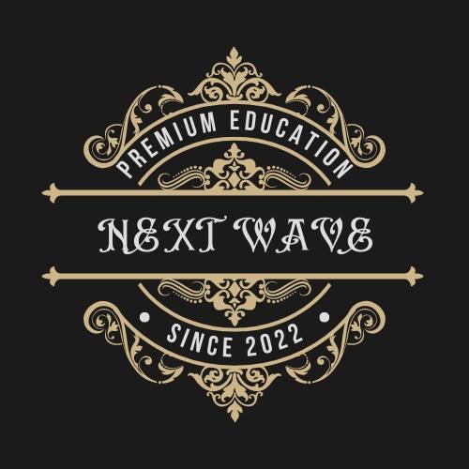

EMAILNEWSLETTER:https://www.canva.com/design/DAFyyCD5noY/REtKBdawWIfPkZGk_bq6iQ/view?utm_content=DAFyyCD5noY&utm_campaign=designshare&utm_medium=link&utm_source=editor